文件编号Doc.code
版本号 Version No | V1.0

产品规格书
Specification

产品名称Part-Name: 超高频螺丝标签
UHF RFID SCREW TAG
产品型号Part-Number： KMR50120819

产品特性 Product Feature
Chip Protocol:（芯片协议：） | EPC Class1 Gen2,ISO 18000-6C
Working Frequency:（工作频率：） | EU:865-868MHz or US:902-928MHz
IC Type:（IC 类型：） | Alien Higgs-3
Memory:（内存：） | EPC 96bit(up to 480bits),User 512bit, TID64bit
Functionality:（功能：） | Read / write(读/写)
Applicable Surface:（适用表面：） | Metal Surfaces(金属表面)
Fixed reader read range  (30dBm/8dBi):（固定读写器读距：） | 80cm-US,
Handheld reader read range  (R2000/3dBi):（手持读写器读距：） | 120cm-US,
Physicial Specification（产品规格：）
Dimension:（尺寸：） | 60mm*18.7mm*12mm
Material:（材料：） | Steel(304不锈钢)
Mounting Methods:（安装工艺：） | Metal Embedded(嵌入金属)
Weight/piece:（每个的重量：） | 50.6g
Environmental Parameter:（环境参数：）
IP Rating:（防水等级：） | IP66
Storage Temperature:（存储温度：） | -40degree to +150 degree
Operation Temperature:（工作温度：） | -40degree to +180 degree

性能曲线参考图Reference of Graphic Performance
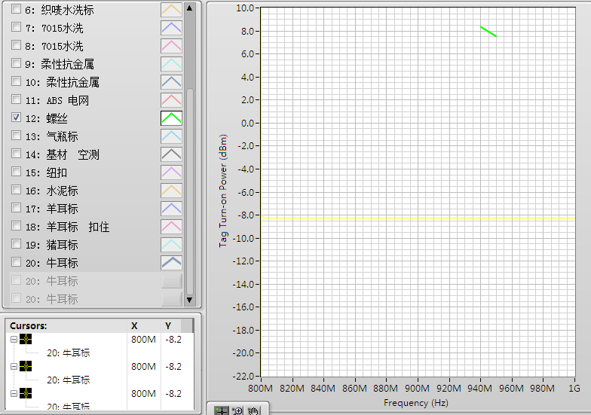

应用场景Application
RFID资产管理，模具管理，大型设备管理，集装箱管理，特殊金属表面管理
窗体底端
RFID asset management,Mold management,big equipment management,container management,or special metal surface management

版权声明 Copyright Statement
1.上述数据是基于本公司对产品特性一般的了解，仅供一般信息参考。客户购买本产品时应在实际应用条件下测试结果来自行决定是否适用。
The above data is based on the company's general understanding of product features and is for general information only. When the customer purchases the product, the test result should be determined according to actual application conditions.

